Charles Leclerc in Bahrain
Student Name: Sooriyapatabedhi D.N.S
IT Number: IT21260438

Summary of the Game Concept
"Charles Leclerc in Bahrain" is a fast-paced, 2D side-scrolling arcade racing game that blends high-speed Formula 1 mechanics with vehicular combat. The player controls a weaponized Ferrari F1 car navigating a dangerous, endless stretch of the Bahrain International Circuit. As the game progresses, the track speed dynamically increases. The player must survive by quickly changing lanes to dodge tire barriers, collecting pit-stop repair kits to manage their health, and using forward-facing energy cannons to destroy aggressive rival vehicles to achieve the highest possible score.
Description of How Core Features are Implemented
- Health System: Managed by the GameManager script, the player starts with a maximum of 3 Health Points (HP). Health is visually represented by a UI Slider. When the player collides with an object tagged Obstacle (tire barriers) or Enemy, a Unity OnTriggerEnter2D function reduces the HP. If HP reaches 0, the game triggers a Game Over state via Time.timeScale = 0f.
- Score System: A TextMeshPro UI element displays the score. Points are awarded in two ways: passing cleanly through invisible ScoreZone trigger colliders positioned in the gaps of track barriers, and by successfully destroying rival vehicles with projectiles.
- Health Packs: Spawning randomly on the track, "Pit Repair" health packs are physics triggers. When the player's F1 car collides with them, the GameManager.Heal() function restores 1 HP (capped at the maximum of 3) and destroys the health pack GameObject.
- Player Projectile Attacks: The player's F1 car features a FirePoint transform on its nose. When the PlayerController detects a left mouse click, it instantiates a spark projectile. The projectile travels right along the X-axis and calls Destroy(gameObject) either upon colliding with an enemy or after a short 2-second lifetime to optimize memory.
- Enemies: Rival vehicles spawn randomly on the right side of the screen and travel left. If they collide with the player, they inflict damage and self-destruct. If they collide with a player's projectile, they are destroyed, and the player is awarded bonus points.
- Increasing Speed Over Time: Instead of accelerating the player, the game accelerates the environment. The GameManager features a globalSpeed float variable that continuously increases using Time.deltaTime. All obstacles, enemies, and health packs reference this globalSpeed to dictate how fast they move left across the screen, creating a smooth difficulty curve.
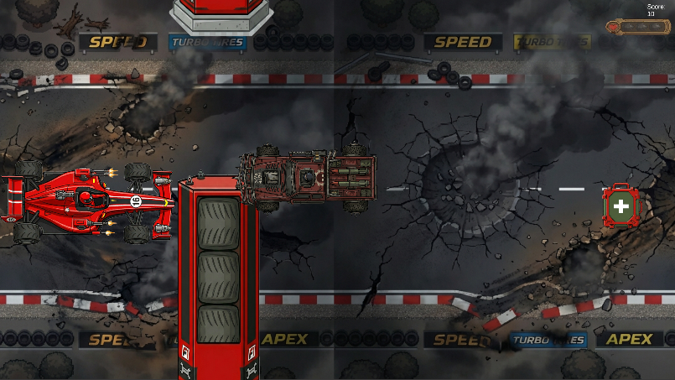
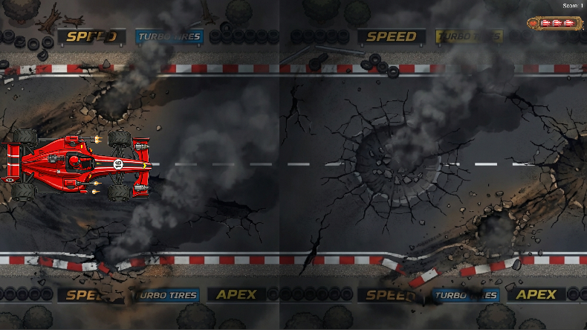
Screenshots of Gameplay
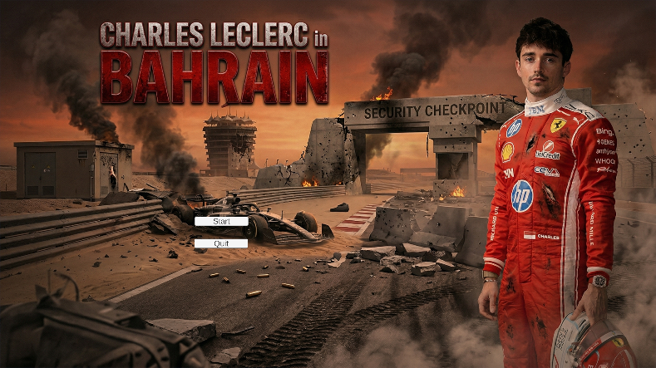
Control Guide
- W / S Keys or Up / Down Arrow Keys: Steer the F1 car up and down between track lanes.
- Left Mouse Button: Fire the dual forward-facing energy cannons.
Description of the Creative Feature
The primary creative modification is the Combat-Racing F1 Theme. Instead of a standard endless runner, the game introduces vehicular combat into a professional racing setting. The player's F1 chassis has been custom-designed to include dual energy weapons, transforming passive dodging into an active "seek and destroy" mechanic against rival racers. This is supported by custom, high-quality 2D sprites (including the weaponized red F1 car, stylized tire barriers, and pit-stop crates) that elevate the visual polish beyond basic geometric shapes.
Credits for External Assets/Tools Used
- Game Engine: Unity Editor Version 6000.0.47f1
- UI Components: TextMeshPro (Unity Technologies)
- 2D Visual Assets: The F1 car, tire barriers, health pack, and track backgrounds were custom-generated using Google Gemini AI image generation tools specifically for this project.
Video Link
Build 2026.03.28 - 04.16.24.04.mp4

